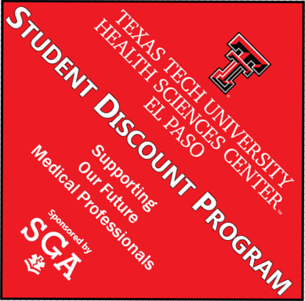
Texas Tech University Health Sciences Center El Paso Student Discount Program
Participation Agreement

Businesses that offer discounts to the students of Texas Tech University Health Sciences Center El Paso (TTUHSC El Paso) will be listed as “free of charge” on the university’s Student Discount Program website, on campus Student Discount Program advertisements, and on any other Student Government Association (SGA) publication or brochure that promotes this program.
If you wish to participate in the TTUHSC El Paso Student Discount Program by offering a discount or free gift to TTUHSC El Paso students, please complete the following registration form and submit via email to sga.elp@ttuhsc.edu or return it to TTUHSC El Paso’s Student Services Office, located on the first floor of the Medical Education Building (5001 El Paso Drive).

Company:
Address:
City: State: Zip:
Phone:
E-mail:
Contact Person:
Your discount offer: (Please be specific; this will be listed on the Student Discount Program website.)
Students will be required to show their official university identification card to obtain the discount.

I wish to participate in the Texas Tech University Health Sciences Center El Paso Student Discount Program sponsored by the TTUHSC El Paso Student Government Association in partnership with the Greater El Paso Chamber of Commerce. I understand the extent, length and level of my participation is solely my discretion, and as such, I may discontinue my involvement at any time upon giving notification to the Student Government Association. I understand that my company's name will be used in all promotional material related to the Texas Tech University Health Sciences Center El Paso Student Discount Program.

______________________________________ __________________
Contact Person Signature Date
My signature does not constitute a contractual obligation, but is rather a pledge of faith that I will do all that is reasonably possible to ensure the success of this program within my organization.
We encourage you to submit this form by email at sga.elp@ttuhsc.edu. However, you may print and fax the form to 915-783-5154 or by mail to:
Student Services
c/o SGA Student Discount Program
Medical Education Building
Room 1210
5001 El Paso Drive
El Paso, Texas 79905

