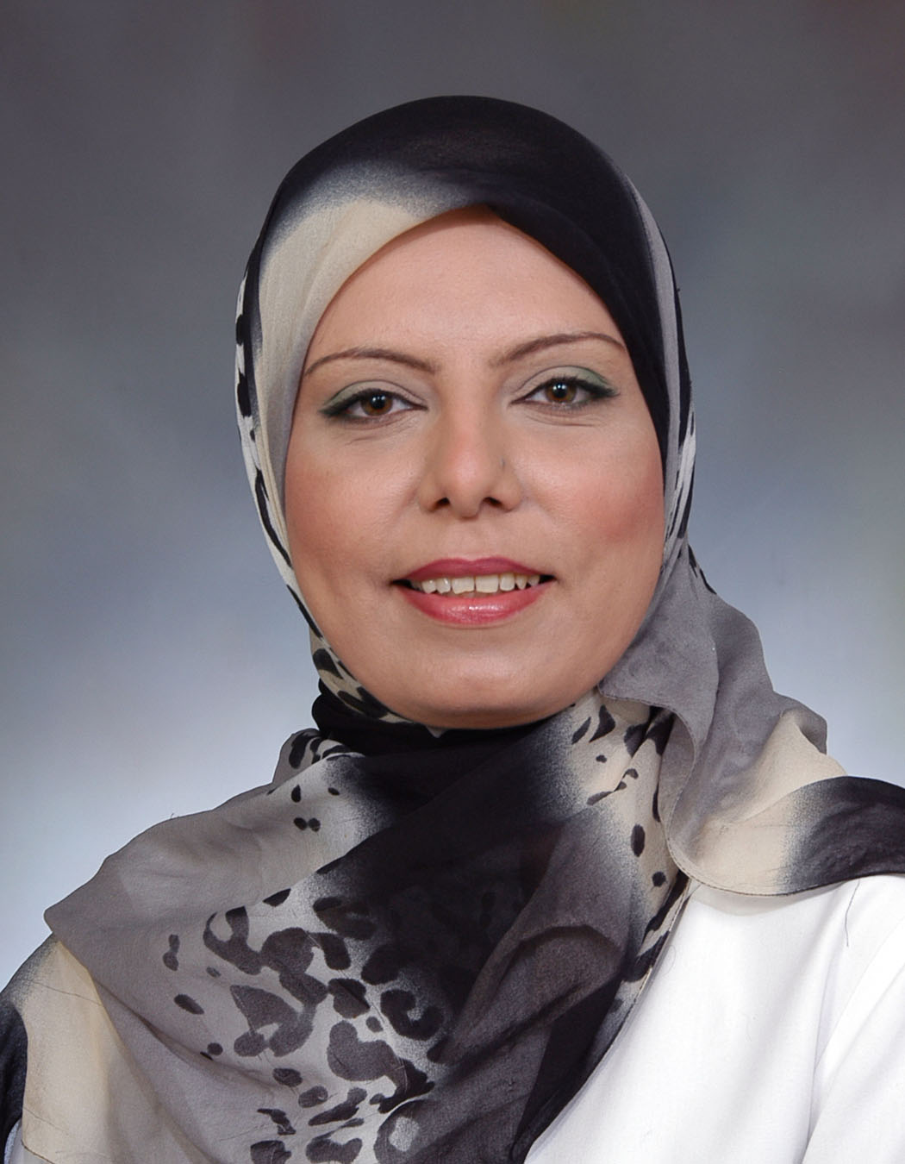  Naima Frewan, M.D. | 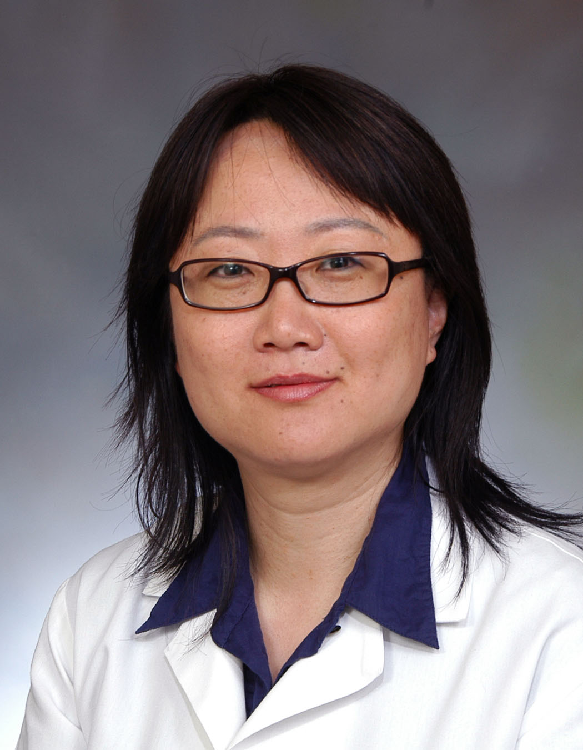  Jian Kang, M.D. |  | 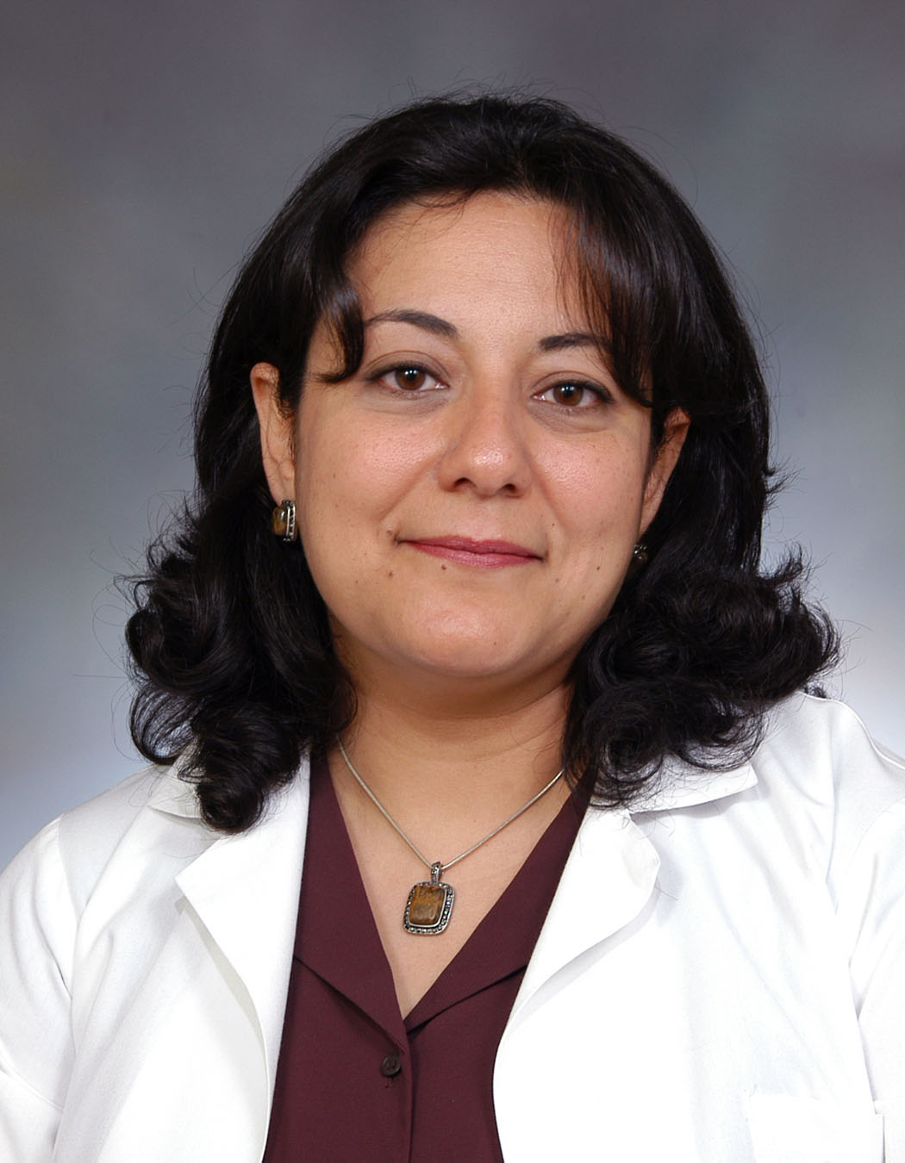  Hala Maraghy, M.D. | 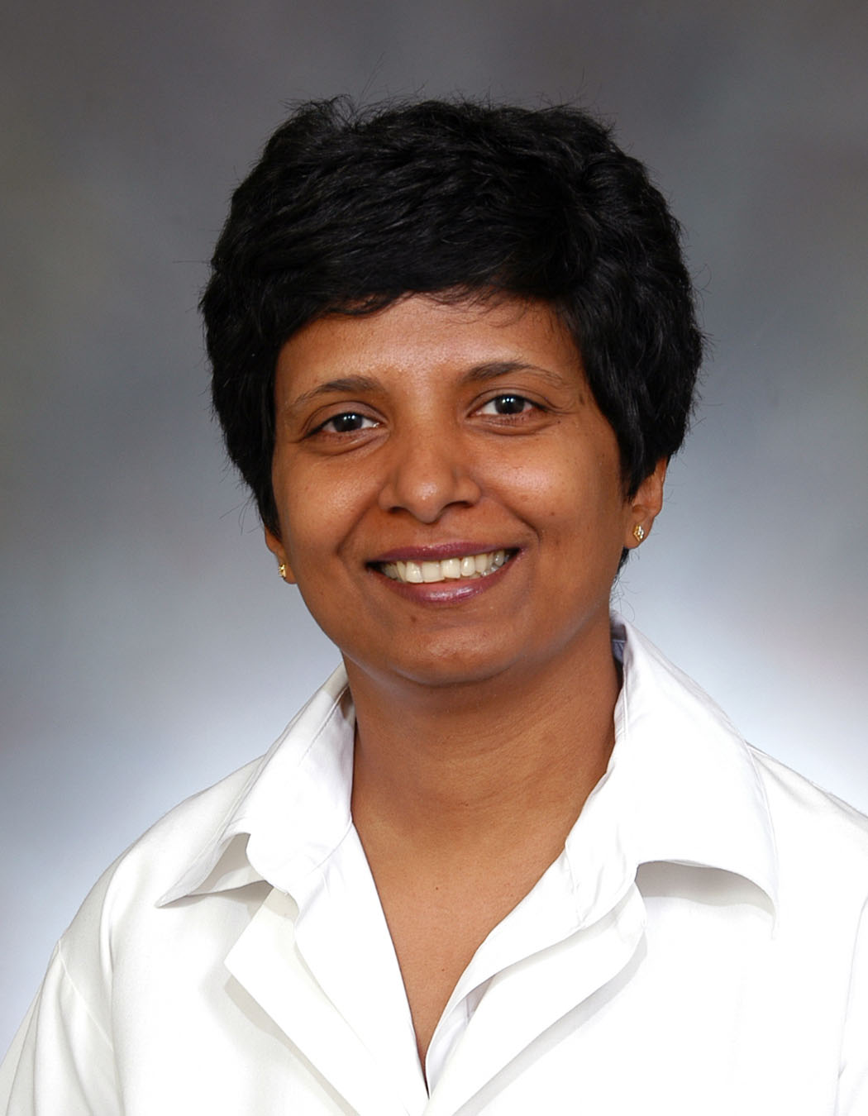  Jyoti Nair, M.D. |   Jesus Peinado, M.D.
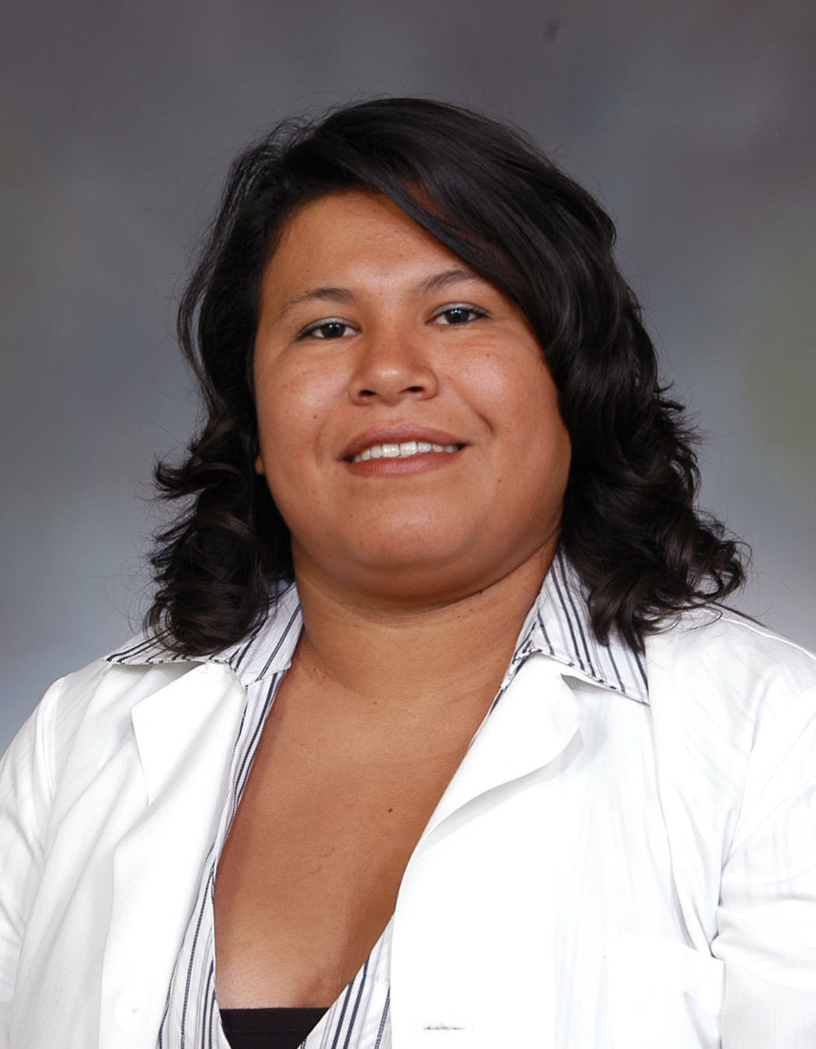  Julia Ruiz, M.D. |   Gervasio Sanchez, M.D. |  |   Darinka Shaw, M.D. |   Wansheng Wang, M.D. | 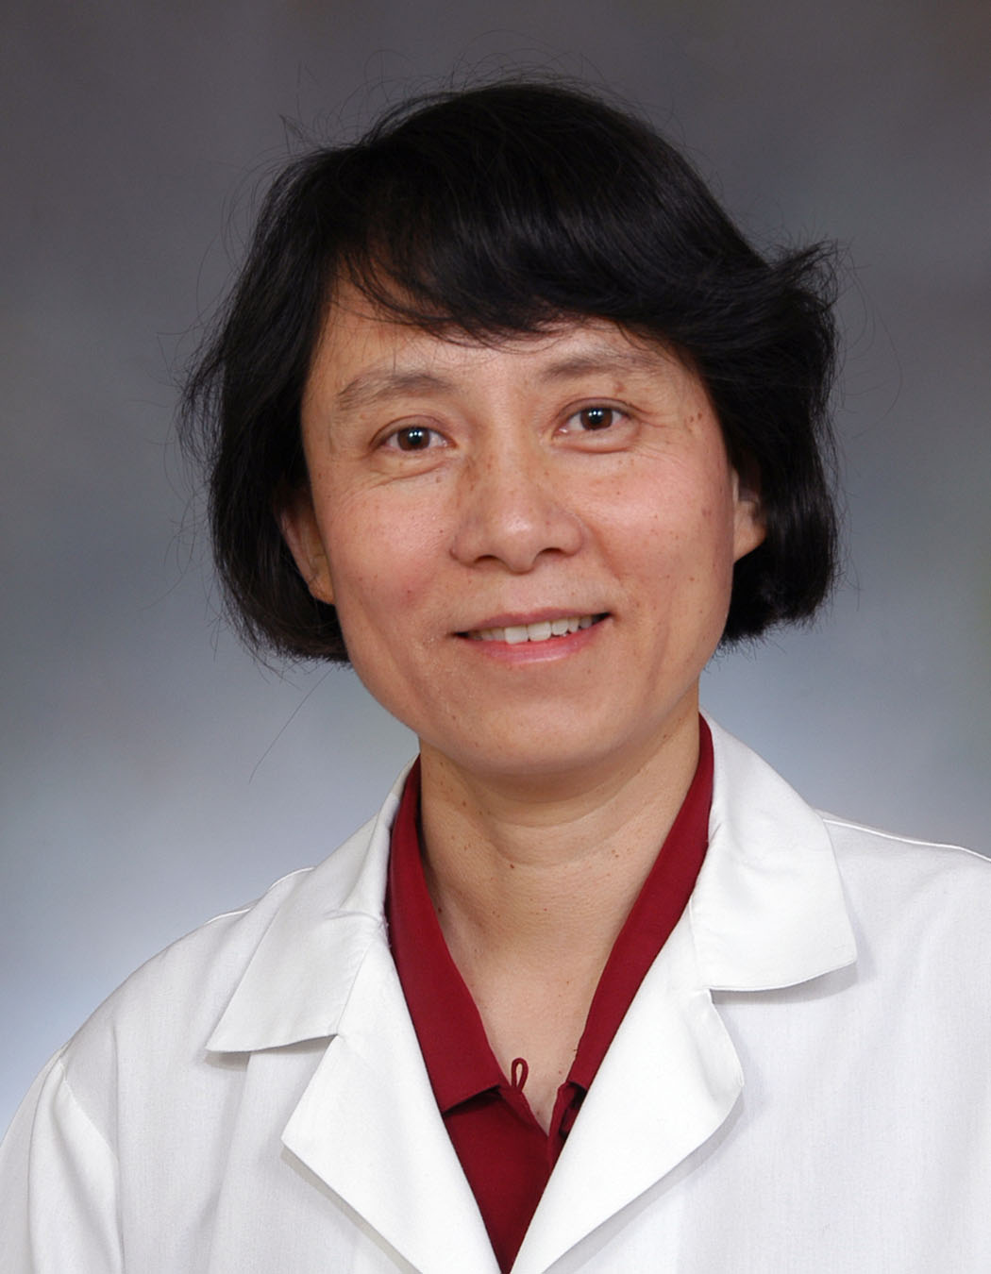  Dong-Xiao Yang, M.D.
PGY – 3
Department of Pediatrics,
2009 -2010

