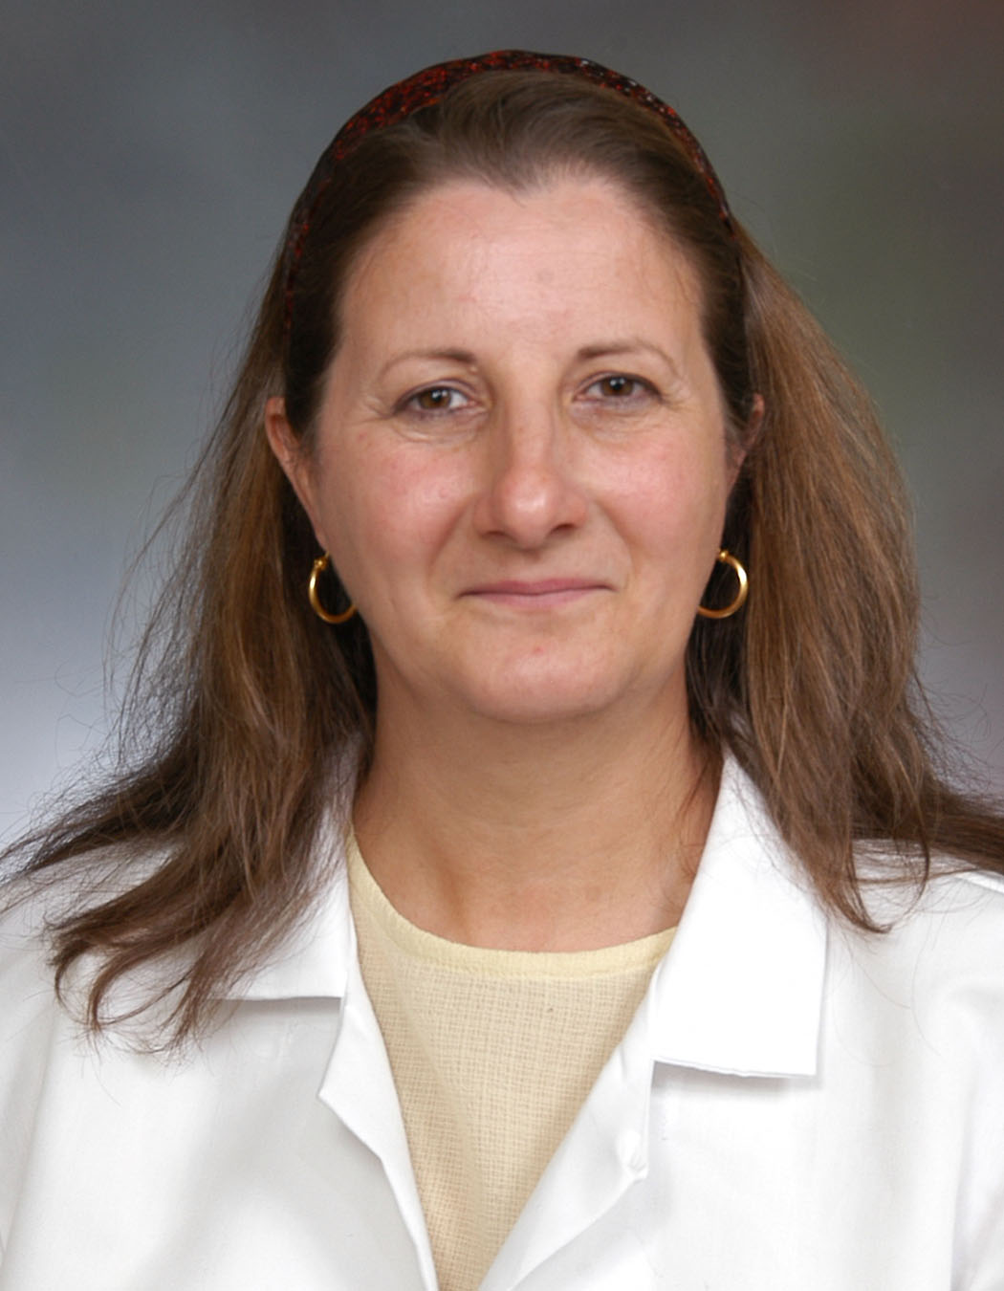  Silvana Al-Chaderchi, M.D. |   Xiuhua Bozarth, M.D. |  | 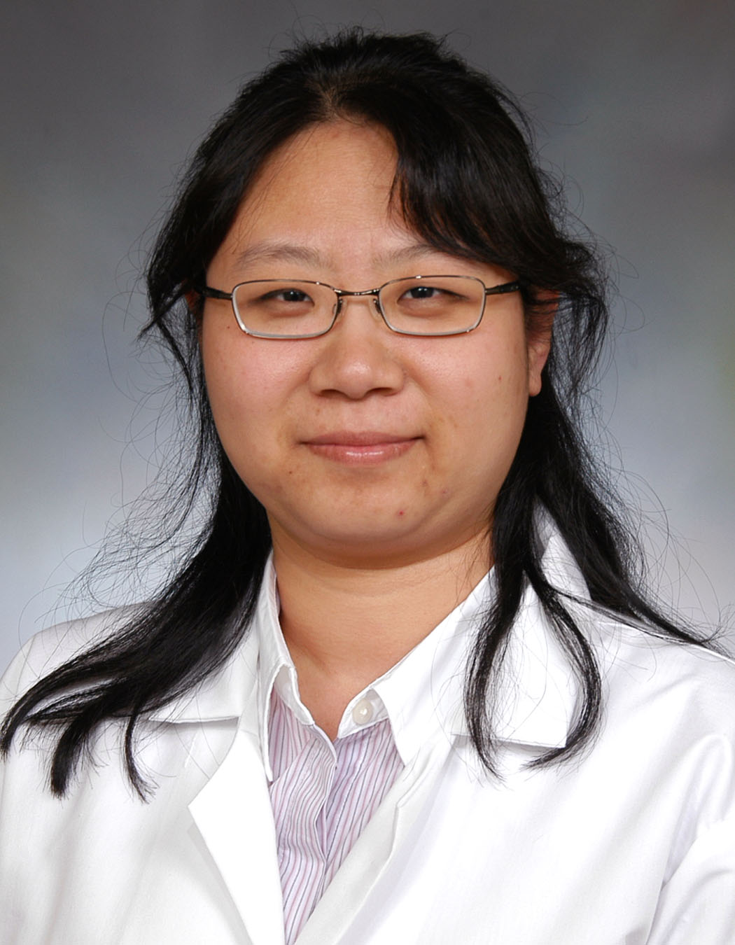  Weili Chang, M.D. | 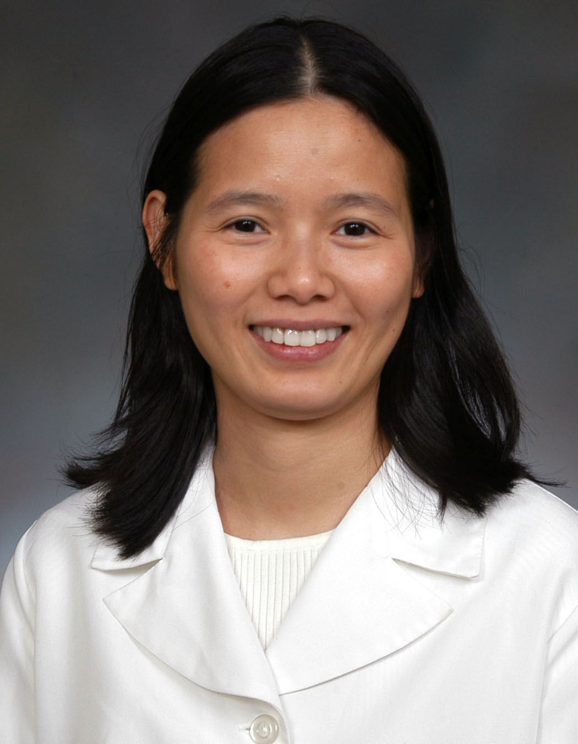  Nhu Do, M.D. | 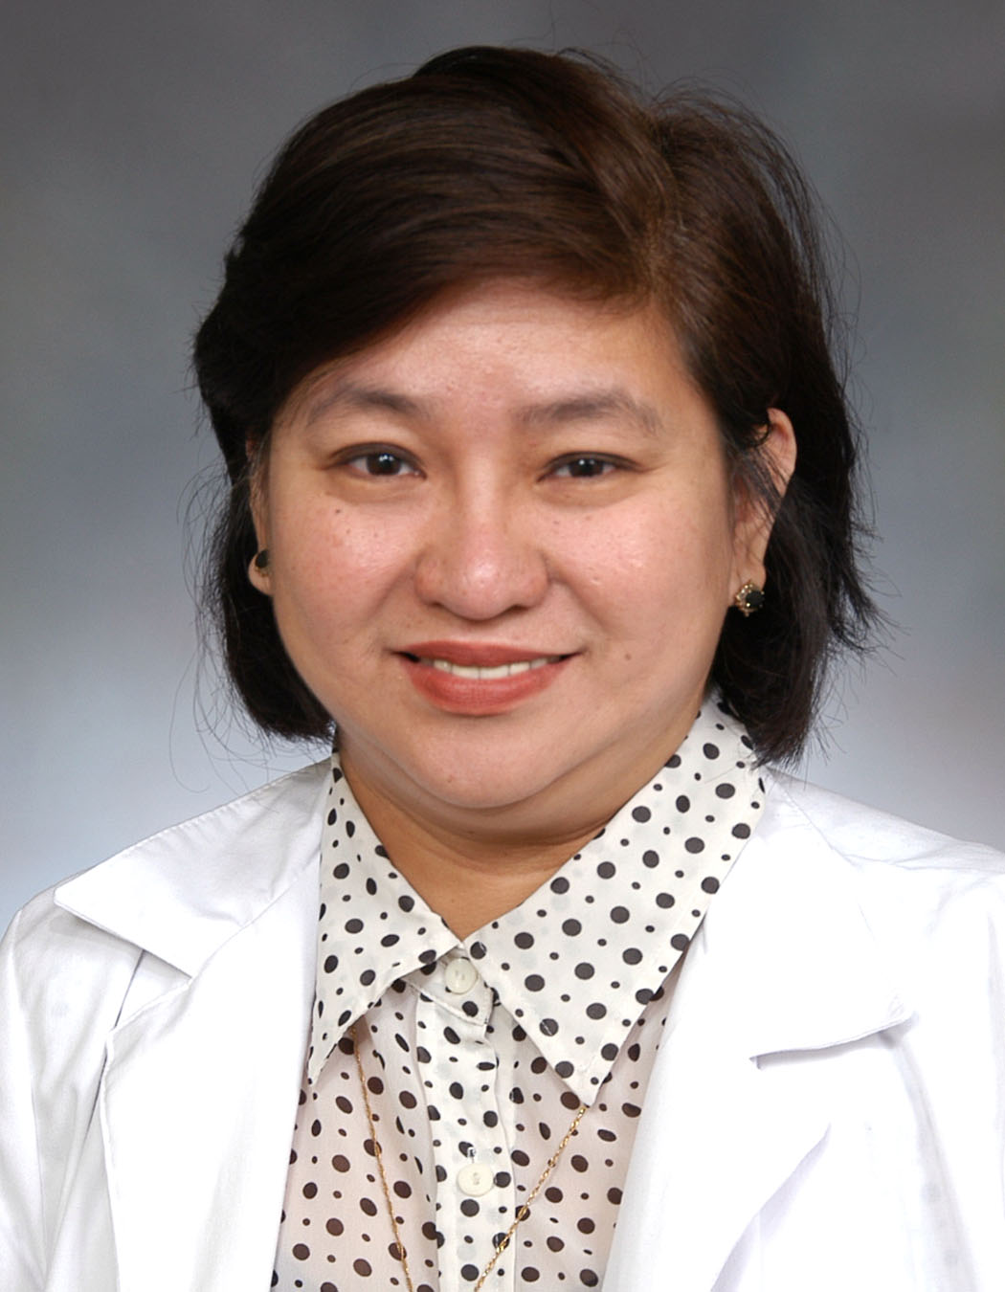  Danela Escueta, M.D.
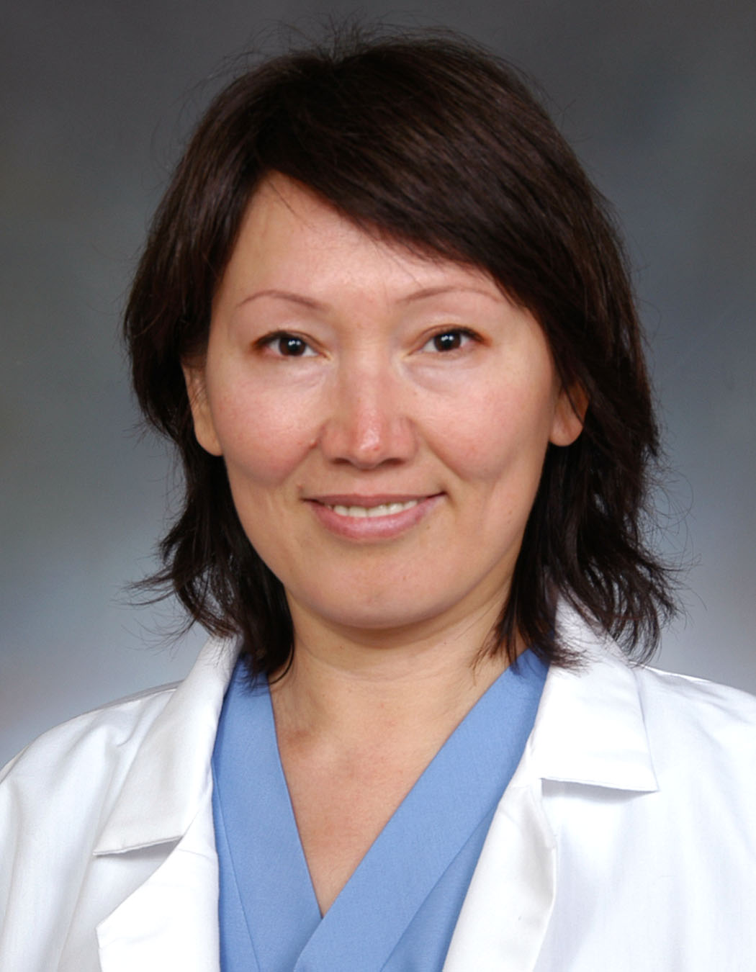  Botagoz Hyams, M.D. | 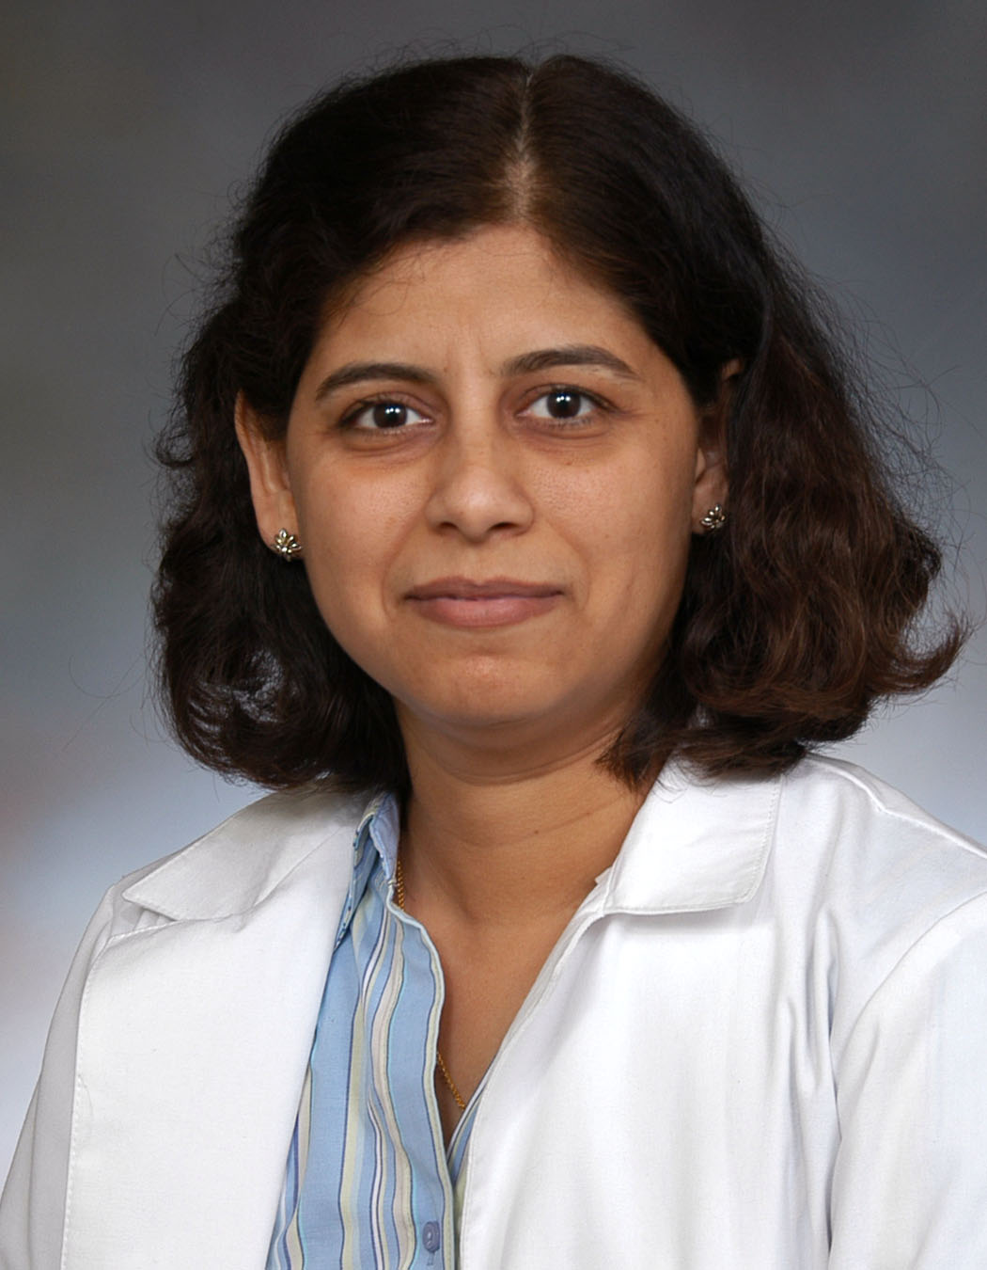  Aparna Jha, M.D. |  |   Emad Lawendy, M.D. | 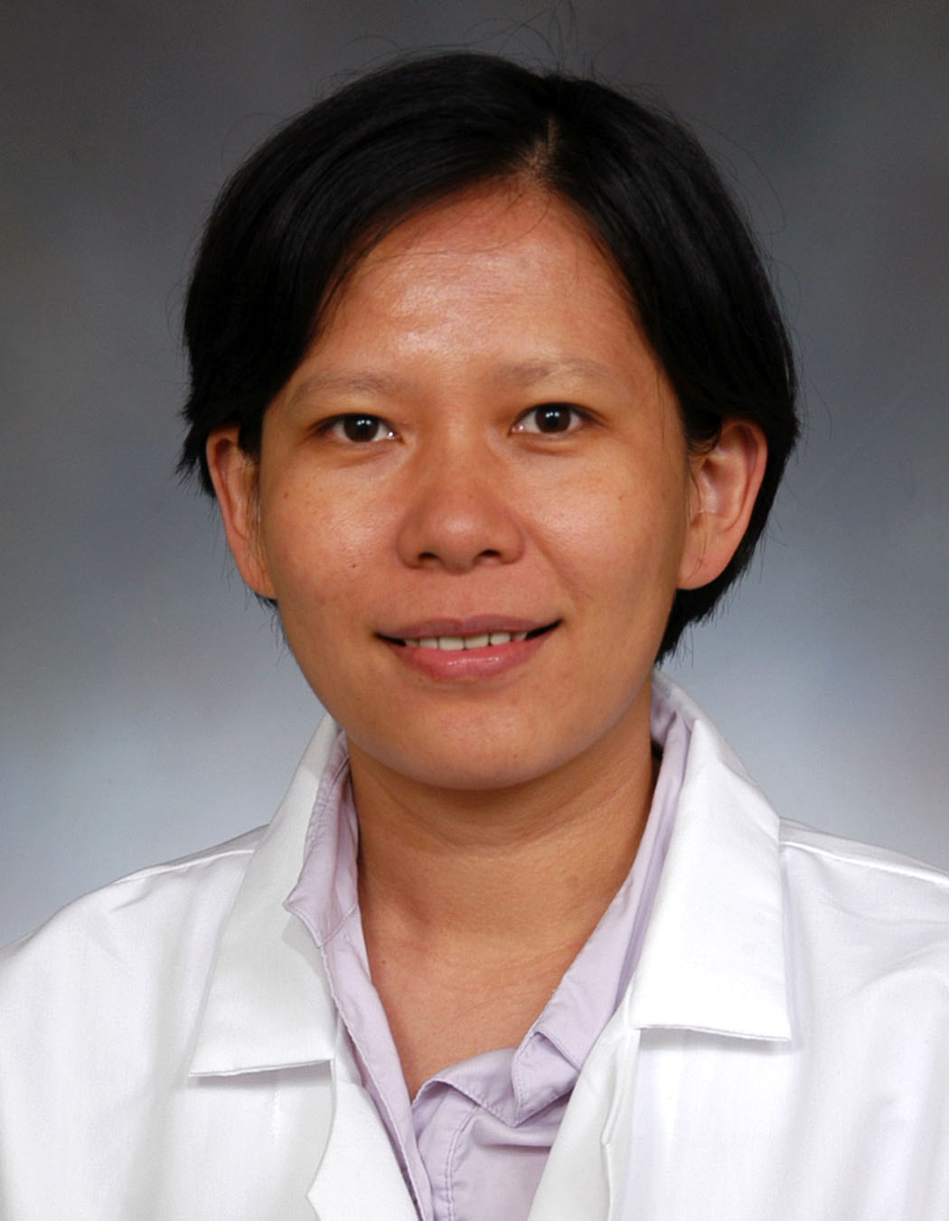  Meiyun Ma, M.D. | 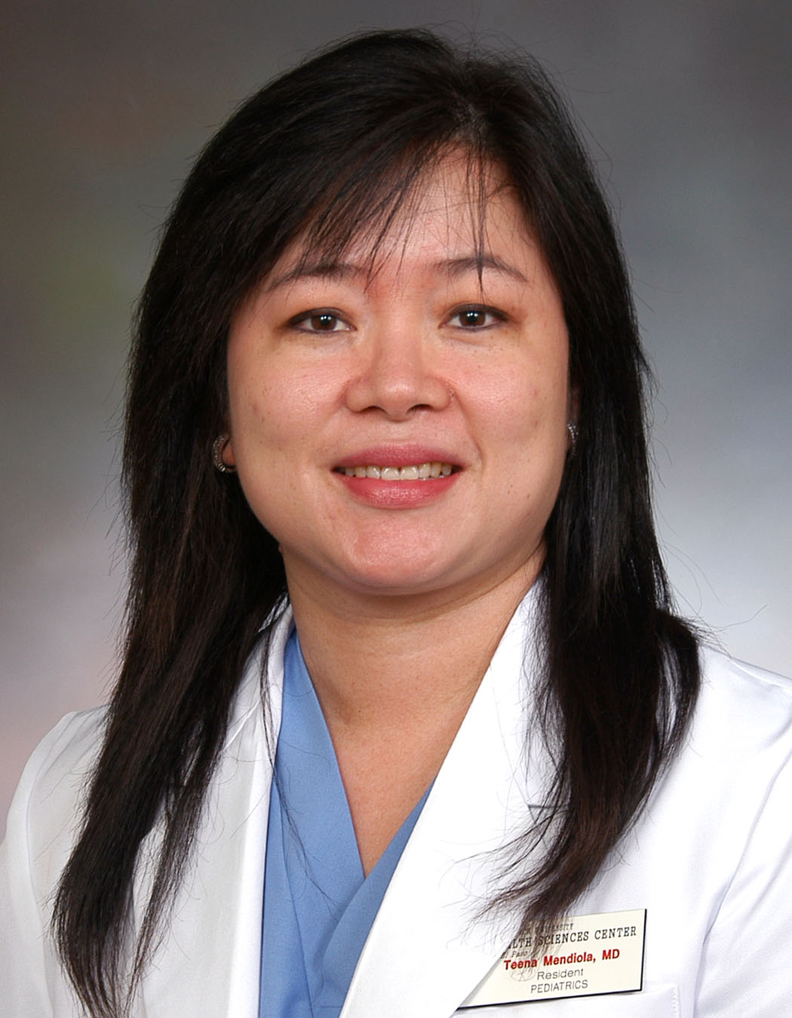  Anna Mendiola, M.D.
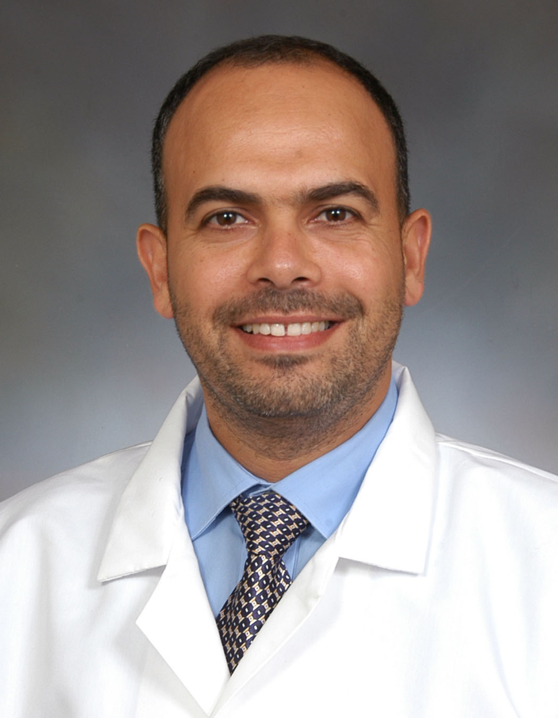  Osama Naga, M.D. | 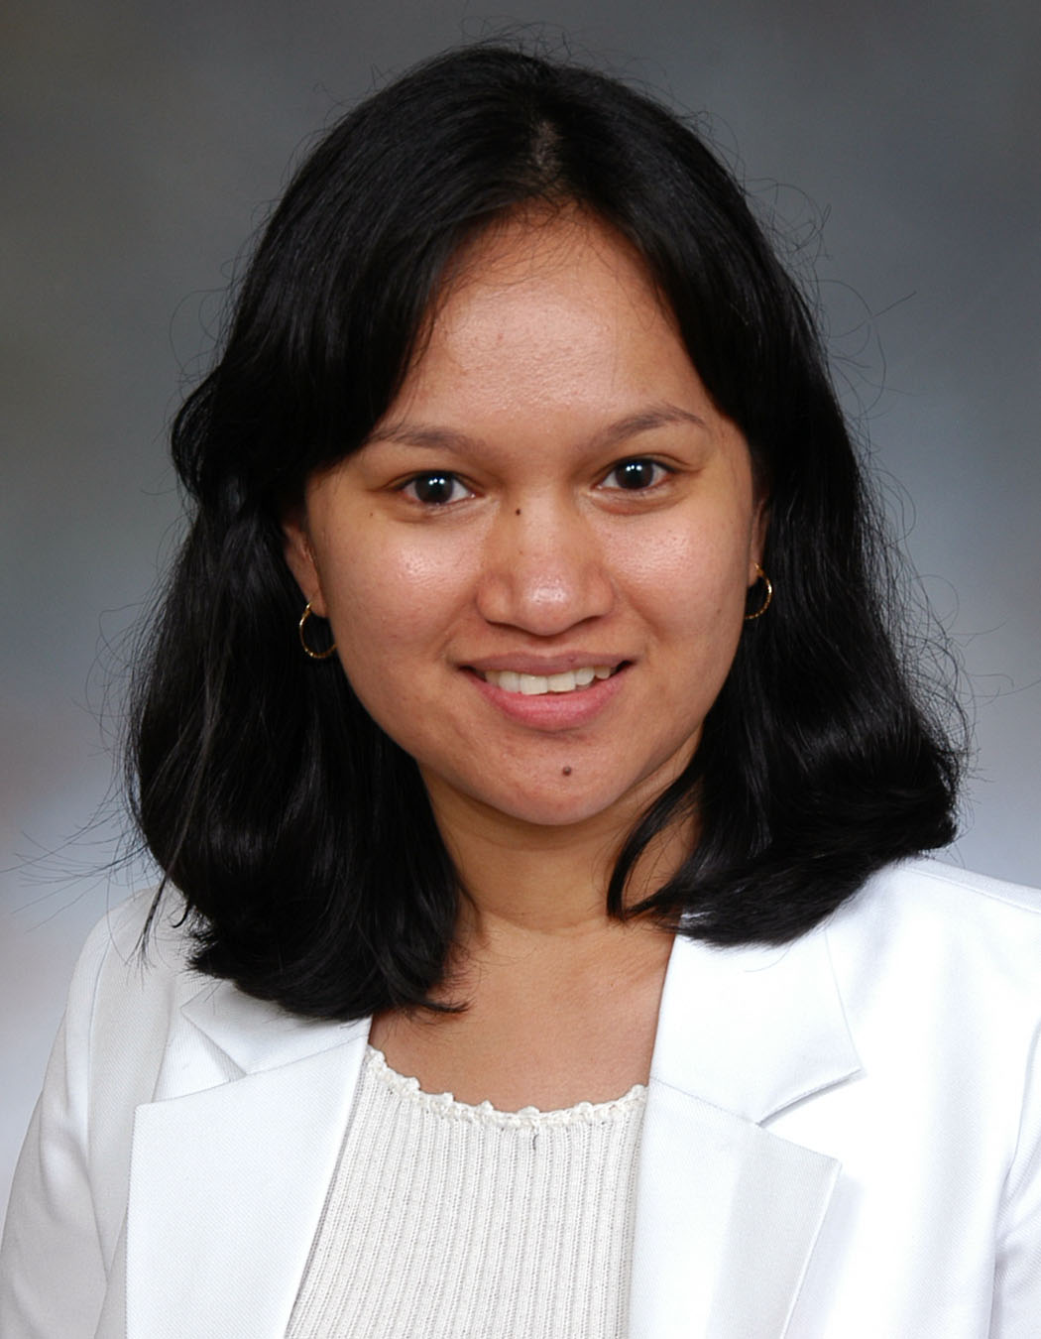  Sheila Saguinsin, M.D. |  | 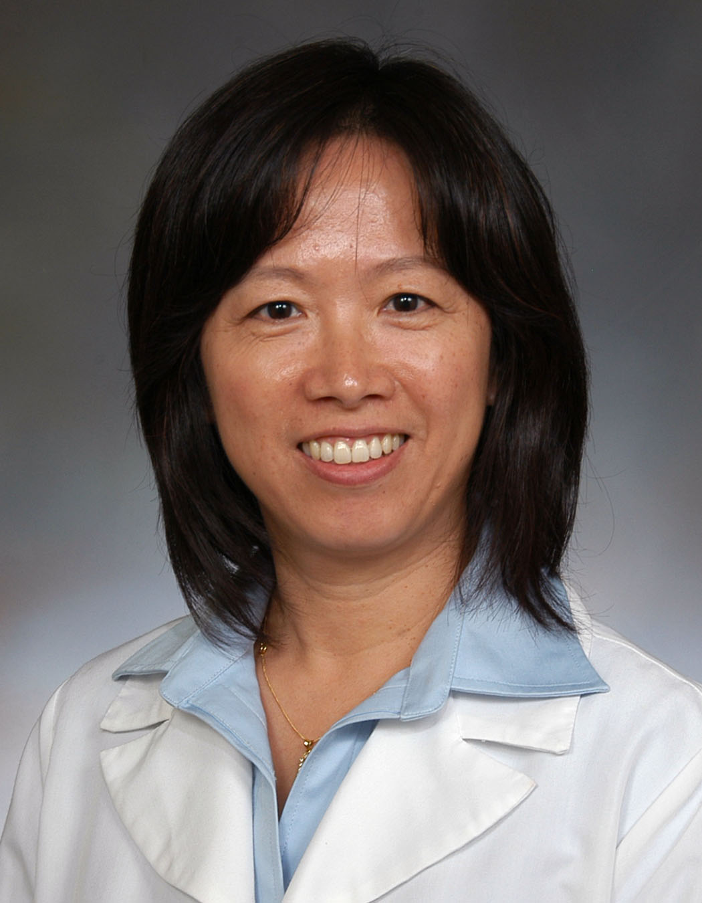  Guifeng Sun, M.D. |  | .
PGY – 2
Department of Pediatrics
2009 -2010

