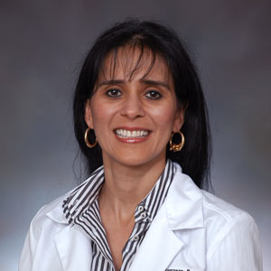  Soraya Barragan-Bonacci, M.D. | 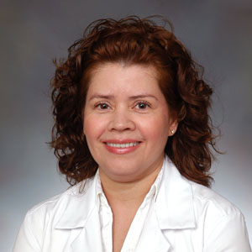  Irma Elena Betty, M.D. | 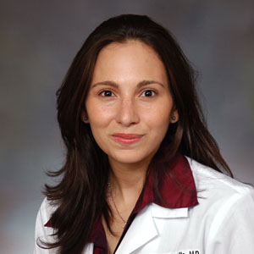  Sabrina Ann Carrillo, M.D. | 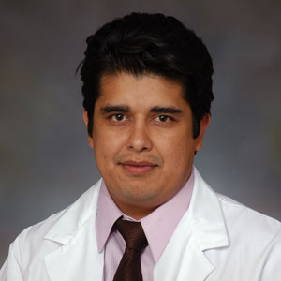  Ariel Chairez, M.D. | 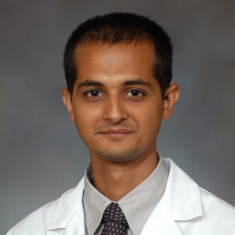  Sastry Chamarthi, M.D.
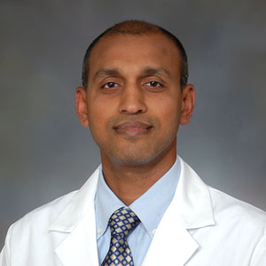  Guru Prasad Krishnamuthy, M.D. | 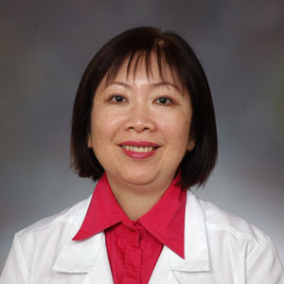  Thanh Le, M.D. | 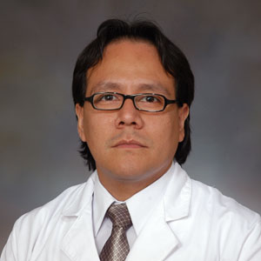  Eric F. Pando, M.D. | 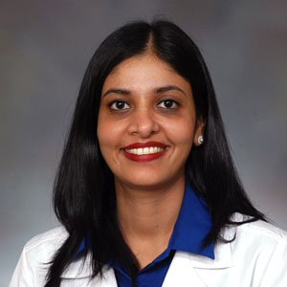  Diana Prasad, M.D. | 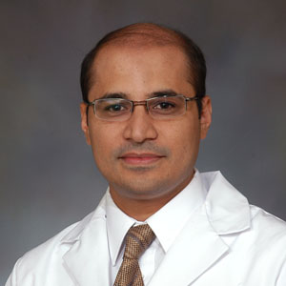  Muddasir Qureshi, M.D.
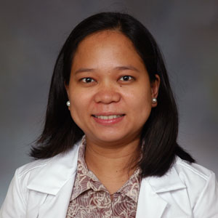  Shelley Lazaro, M.D. | 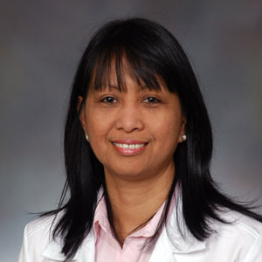  Wilhelmina Santiago, M.D. | 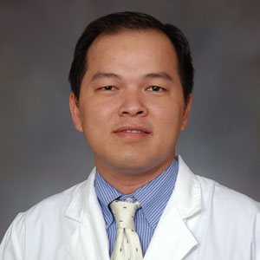  Hung Truong, M.D. | 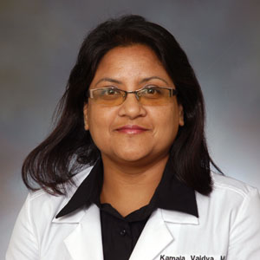  Kamala Vaidya, M.D. | 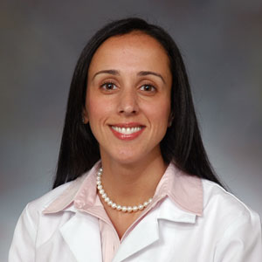  Janel Zacchilli, D.O.
PGY – 1
Department of Pediatrics
2009 -2010

