[](http://www.dshs.state.tx.us/)

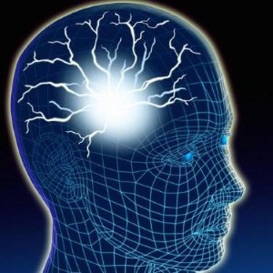

**Epilepsy services provide comprehensive outpatient care to eligible persons who have epilepsy and/or seizure-like symptom**

***Servicios Comperensivos de epilepsia a personas eligible que tienen epilepsia/ or sintomas parecidos****.*

**If you are uninsured and have Epilepsy/Seizures you may qualify for our program that covers office visits** **with your physician. Social Services are also available.**

***Si usted* no *tiene seguro medico y tiene Epilepsia, ataques/convulsions podria calificar para nuestro programa que cubre visitas con el medico. Servicios Sociales tambien estan disponibles****.*

*Please contact/***Personas de contacto:**

***Lourdes Martinez, LBSW Pat Miranda, CMA, CMAA, NA***

***Social Worker Patient Service Specialist***

***Departamento de Neurologia Departamento de Neurologia***

***Phone: (915) 215-5921 Phone: (915) 215-5921***

***Fax: (915) 545-6705 Fax: (915) 545-6705***