Guidelines for the SARP Course Project Plan (PSAP 5401)

The Project Plan is a submission to fulfill the first credit of the three credit SARP Course requirement. The Project Plan must be developed with the help of your SARP Course project mentor and needs to describe your project in enough detail to allow a reviewer of the document a clear understanding of your research question or hypothesis, the specific aims of the project, what methods you will use to address these aims, what data, or information you will acquire and what analytic approaches you plan to use. Further, a detailed timeline of the project needs to be included.

Project Plan Points of Emphasis
- For access to the SARP Syllabus, Guidelines, and additional information, please visit the SARP Website. The SARP webpage is part of the TTUHSC El Paso website and is located under the Department of Medical Education. It can be found within the Scholarly Activities and Research section.
- If you have any questions or concerns about your SARP Course Project Plan, don’t hesitate to contact the SARP Course Faculty Co-Directors or the SARP Director.
- Your SARP Course project mentor is responsible for helping you develop your project in all its aspects. Work proactively to develop a solid working relationship with your mentor to maximize both the success of your project and your professional development.
- It is essential to engage in conversations with mentors before including them in the Project Plan.
- The Project Plan needs to be authored by you, representing original work. You must take ownership of the Project Plan and be responsible for its content.
- Group projects are allowed (with up to 5 students working with a single mentor); however, each student should clearly identify a unique research question or hypothesis that can distinguish their contribution and provide for an independent Project Plan, Final Report, and Poster presentation, in fulfillment of the SARP Course credits.
- The SARP Course is designed to provide scholarship / research to enhance your medical school experience, and credit will be given for work done while you are enrolled at the FSOM. Scholarship or research pursued before matriculating to the FSOM cannot be used directly in fulfillment of the SARP Course requirement; however, continuing work on earlier projects, potentially continuing work with a previous mentor, is allowed if you clearly document how your SARP Course activities are extensions of such previous work.
- Please note that case studies or narrative reviews are not considered sufficient to meet the SARP Course Project requirement. However, meta-analysis or systematic reviews are acceptable. For information on different types of scientific reviews, please see this helpful publication: A typology of reviews: an analysis of 14 review types and associated methodologies.
- An excellent resource to become familiar with is the AMA Style Manual, which provides comprehensive guidelines for preparing uniform technical documents. A full PDF version is available: https://authorservices.wiley.com/asset/Wiley-AMA-Style-Manual.pdf
- Your Project Plan must be submitted electronically. You will receive emails reminding you of this deadline. Your SARP project mentor will receive a notification requiring acknowledgement of their mentoring responsibility.
- For those with external mentors, students must have permission to present external work at the SARP symposium.

Project Plan Contents
Your SARP Course Project Plan should contain the following elements:
- Title of Project, a concise sentence or phrase to describe the overall project.
- Mentor name and contact information

Be certain to work closely with your mentor on developing your Project Plan. Your mentor will formally sign-off on this document through the REDCap software.

Project Background and Significance
This should be a concise introduction to the topic of your project and include citations of primary literature to support the development of your ideas, providing a logical foundation for your research question or hypothesis.

Research Question or Hypothesis
This is a one sentence statement of the project’s overall focus as an explicit research question or hypothesis to be addressed.

Specific Aims with Rationale
The Specific Aims should be a small set of concise one- or two-sentence summaries of what you expect to achieve in executing your SARP Course project. A short paragraph should accompany each Specific Aim to provide a rationale for how the Aim addresses the project’s research question or hypothesis.

Methods
This will be a short description of the methods (employing techniques, materials, databases, surveys, etc.) you intend to use to directly accomplish your Specific Aims.

Analysis
This section describes the methods you will use to analyze your data. For basic research and community / epidemiology projects, this could include a description of the statistical methods to be employed. For a medical humanities or ethics project, this might involve narrative or reflective analysis.

Compliance
If your SARP Course project requires compliance approval for using human subjects (IRB), animals (IACUC), or biohazardous materials (IBC), it is your responsibility to work with your mentor to document these in your Project Plan and clearly describe what compliance is in place or the schedule for obtaining compliance. Please note no data collection should occur without compliance documentation being approved by the institution.

Timeline
Provide a timeline for executing your SARP Course project and when you expect to submit your Final Report. There are 3 tracks to complete your SARP Course project: choose one for creating a timeline for this Project Plan document. However, you can change your Track, if necessary, by submitting a Progress Report. For example, if you submit your Project Plan expecting to complete your SARP Course by Track 1, you can change to Track 2 by submitting a Progress Report on the due date for the Track 1 Final Report. The diagram below outlines the three available Tracks and schedules:

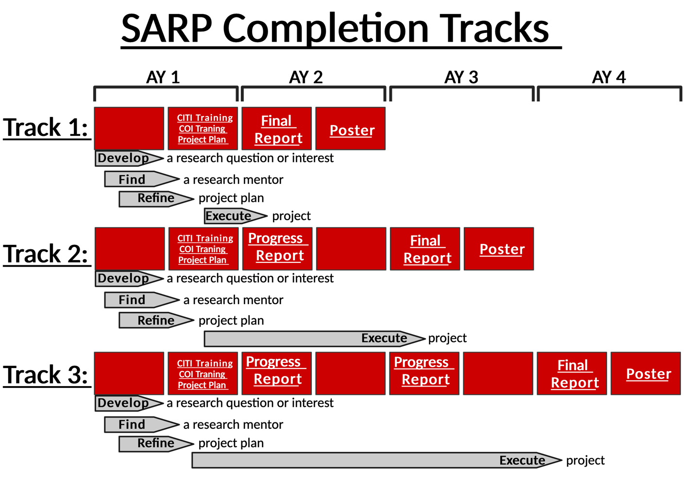
Figure 1

Additional considerations for developing your Project Plan:
- Your Project Plan will be assessed by a faculty member using a grading rubric available in the SARP Syllabus. Review this assessment rubric so you’re familiar with how elements of your Project Plan will be graded.

- Be certain to work closely with your mentor on project planning and obtain and incorporate feedback on all drafts and the submitted Project Plan.
- Provide relevant citations and a bibliography using the format suggested in the AMA Style Manual.

Be certain to read the cited references so the Project Plan has scholarly integrity.
- Edit your Project Plan carefully:
- Proofread (suggestion: have a naïve reader look at your final draft).
- Check spelling
- Check grammar: punctuation, sentence structure, subject-verb agreement (plural or singular), tense consistency, etc.
- Be certain your SARP Course project mentor is actively involved in this process.
- If you are accepted to a summer research program that does not provide explicit information about your mentor or project, work with the program directors so you can submit a ‘placeholder’ Project Plan by the deadline and propose a date you will submit a complete Project Plan.

Integrity Issues
- Students are required to demonstrate a high level of intellectual and personal integrity during all activities related to completion of the SARP Course, in alignment with their professional identity formation as physicians. This includes communicating clearly and honestly and treating all staff, students, faculty and other participants with respect and dignity.
- Write your own reports. Do not plagiarize, and if significant content derives from published materials, cite appropriately. ChatGPT or other Artificial Intelligence-derived content used in any component of your submitted assignments for the SARP Course must be clearly identified.

Submitting the SARP Course Project Plan:
In addition to the Project Plan contents described, your Project Plan requires a Cover Page that includes the following information and format:
- Heading: SARP Course Project Plan
- Student name and R-number
- Expected graduation class (e.g., C2029)
- Student email address
- Date
- Title of SARP Course project
- Mentor name and affiliation
- Mentor email address
- Expected completion date for the SARP Course (i.e., choose Track 1, 2, or 3).

The entire Project Plan document, including a Cover Page needs to be submitted electronically. Instructions for submission will be available through emails and on the SARP Website. Please use the following format for naming the submitted Project Plan PDF:

Last name_First name_C2029_Project_Plan_04.13.2026

Your Project Plan must be submitted electronically. You will receive emails reminding you of this deadline. Your SARP project mentor will receive a notification to acknowledge their mentoring responsibility and must sign off on the Project Plan for the submission to be considered complete.

Grading of the SARP Course Project Plan
The SARP Course Project Plan will first be triaged by the SARP Director to assure that all required textual elements are included; if not, the student will be notified and allowed a 3-day grace period to resubmit a complete Project Plan; if not submitted by this deadline students will meet with the SARP Faculty Co-Directors and their College Mentor to discuss the situation, along with a notation in their SARP Professionalism Report. Following grading by a FSOM faculty reviewer using a grading rubric (available in the SARP Syllabus and on the SARP Website) a Pass or Not-Yet-Pass determination will be made. If Pass, the grading rubric will be deposited in the individual student’s ePortfolio. If Not-Yet-Pass, the student will be contacted by email, the grading rubric included, and provided 2 weeks to revise and resubmit the Project Plan. The revised Project Plan will be re-reviewed by the original reviewer and the SARP Faculty Co-Directors. If Pass, the grading rubric for the revised Project Plan will be deposited in the individual student’s ePortfolio. If Not-Yet-Pass, the student will receive a grade of ‘FA’ (Fail) on their official transcript for PSAP 5401 and will be referred to the Committee on Student Grading and Promotion (GPC).

SARP Course Objectives for Project Plan:
The following SARP Course Objectives are addressed by completing the SARP Course Project Plan:
  - Objective 1: Students will apply the scientific method by developing a research question or project theme, identifying a faculty mentor, and completing all requirements for the SARP Course.
  - Objective 2: Students will learn how to search the literature, identifying previous knowledge and theory that provides context and relevance for their project.
  - Objective 3: Students will submit a Project Plan that follows the scientific method principles, including a research question or hypothesis, specific aims, rationale, methods, analysis, and timeline.
  - Objective 4: Students will choose and employ adequate methods for the acquisition and statistical analysis of data and information for their project.
  - Objective 6: Students will demonstrate clear and effective communication skills (oral and written) in the presentation of their project.
  - Objective 7: Students will learn about protection of human and animal subjects involved in research.
  - Objective 8: Students will learn and exhibit ethical principles in the design and execution of their projects.
  - Objective 9: Students will exhibit attitudes and behaviors consistent with professional conduct of research and scholarship.
  - Objective 10: Students will submit each assignment by the deadline and respond to all communications and feedback in a timely and professional matter.
  - Objective 11: Students will collaborate generously and professionally with their mentor, faculty, students, and staff during completion of their research project.
  - Objective 12: Students will learn principles of self-directed and life-long learning and apply these to the design and execution of their projects.
  - Objective 13: Students will learn the principles of self-efficacy, monitoring and sharing personal progress through self-evaluation and reflection, and SARP Course evaluation.

SARP Project Plan Assessment Rubric

Reviewer Grading Rubric for SARP Course Project Plan
Instructions for Reviewer: Please use the following category descriptors to give the student feedback on the quality of his/her project. This rubric is meant to provide the student with a feel for how well they did relative to both their peers and your expectations for a project at this stage of their career. Additionally, please provide narrative feedback regarding the strengths of the project plan as well as any areas where you see potential for improvement.
Student Name:
Student Mentor:
Project Title:
Project Background and Significance
Needs Improvement | The project theme or significance is missing or poorly defined. Supporting evidence from the literature is missing or inadequate, failing to provide relevant background information or context.
Satisfactory | The project theme or significance is present but lacks clarity or specificity. Supporting evidence from the literature is present but may lack depth or fails to address key sources or perspectives.
Excellent | The project theme or significance is clearly defined, focused, and demonstrates originality and relevance to the field of study. Supporting evidence from the literature is comprehensive, demonstrating a thorough understanding of existing knowledge in the field and critically analyzing relevant sources.
Research Question or Hypothesis
Needs Improvement | The research question or hypothesis is missing or poorly defined. Supporting evidence from the literature is missing or inadequate, failing to provide relevant background information or context.
Satisfactory | The research question or hypothesis is present but lacks clarity or specificity.
Excellent | The research question or hypothesis is clearly defined, focused, and demonstrates originality and relevance to the field of study.
Rationale and Specific Aims
Needs Improvement | The rationale for the research or project aims are weak or unclear, lacking justification for significance or relevance.
Satisfactory | The rationale for the research or project aims is somewhat clear but lacks strong justification or fails to link aims to the research question or project theme.
Excellent | The rationale for the research or project aims is well-justified, logically presented, and convincingly argues for the importance and relevance of the proposed work.
Project Design and Methods
Needs Improvement | The project design is missing or poorly described, lacking key components or not aligned with the research question or project aims.
Satisfactory | The project design is present but lacks some details.
Excellent | The project design is clear, well-structured, and demonstrates a comprehensive understanding of the research methods and procedures necessary to address the research question or project aims.
Analysis Plan
Needs Improvement | The analysis plan is missing or insufficiently described, lacking clarity or failing to align with the research question or project aims.
Satisfactory | The analysis plan is present but lacks detail or fails to explain the appropriate statistical or analytical methods.
Excellent | The analysis plan is well-defined, appropriate for the research question or project aims, and demonstrates a sound understanding of statistical or analytical methods.
Writing
Needs Improvement | The proposal is poorly written, containing numerous grammatical errors, lack of organization, and incoherent structure. Citations are non-existent or inconsistently formatted, or inappropriate.
Satisfactory | The proposal is generally well-written but contains some grammatical or structural issues that affect clarity or readability. Citations present and appropriate with mostly consistent formatting.
Excellent | The proposal is well-written, clear, and effectively communicates the research question or project aims, methods, rationale, and findings. Citations present and appropriate with consistent formatting.
Overall Project Plan
Needs Improvement | There are significant concerns regarding the quality of this project plan. There are significant concerns regarding the research and academic integrity, including potential ethical issues
Satisfactory | The project plan provides sufficient information but there are minor concerns or oversights. The proposal demonstrates awareness of research and academic integrity, but there are minor concerns or oversights.
Excellent | The project plan is well-justified, logical, and convincingly presented effectively communicating all aspects of the plan. The proposal shows a strong commitment to research and academic integrity, including appropriate ethical considerations, transparent data collection and analysis, and accurate and consistent citations.
If a reviewer classifies your overall Project Plan as “needs improvement” consult with your project mentor to revise your Project Plan based on the reviewer provided feedback.
Reviewer Comments:

