Guidelines for the SARP Course Progress Report

Progress Reports are due for students completing their SARP Course by Track 2 or Track 3 (Figure 1). A Progress Report will provide a concise update on the status of your SARP Course project and must be approved by your SARP Course project mentor.

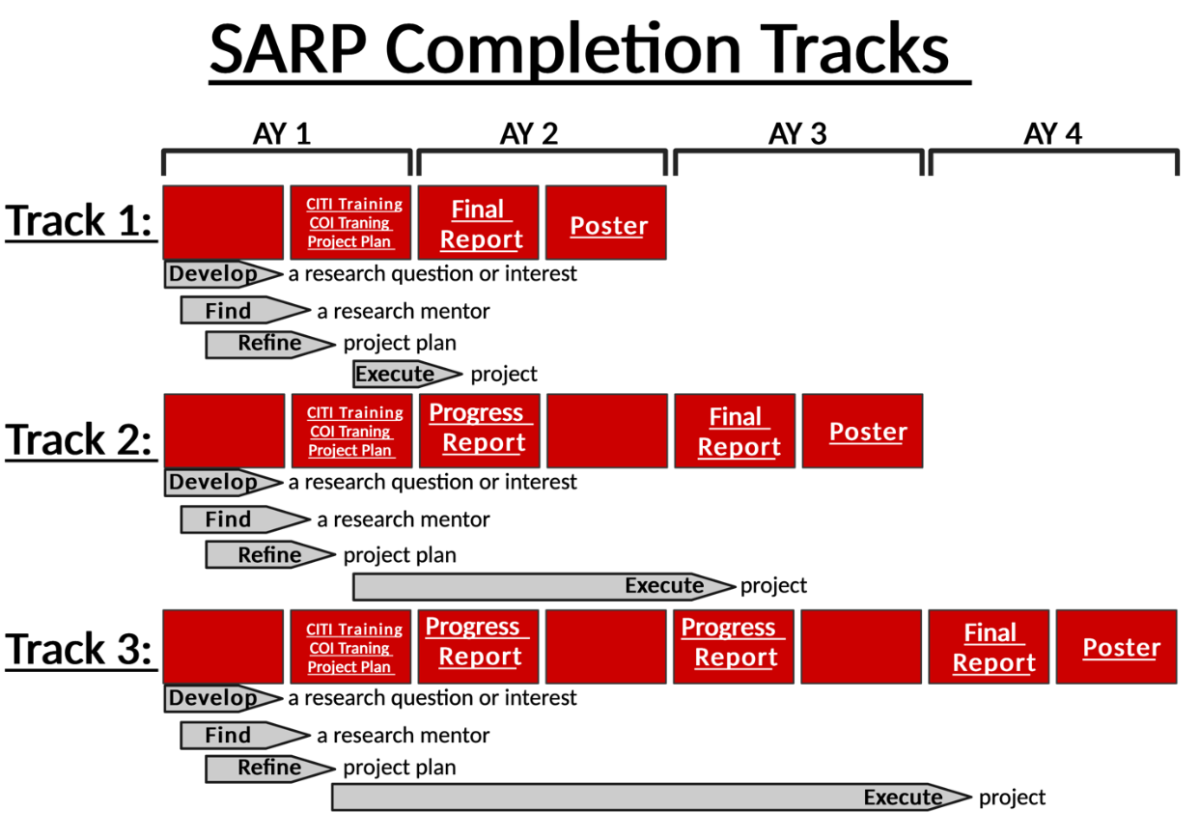
Figure 1

Progress Report Points of Emphasis

- If you have any questions or concerns about your SARP Course Project Progress Report, don’t hesitate to contact the SARP Course Faculty Co-Directors or SARP Director via SARP-ELP@ttuhsc.edu. Deadlines and additional information are available on the SARP Website. The SARP webpage is part of the TTUHSC El Paso website and is located under the Department of Medical Education. It can be found within the Scholarly Activities and Research section.

- Your SARP Course project mentor is responsible for approving your Progress Report. Work proactively to develop a solid working relationship with your mentor to maximize both the success of your project and your professional development.

- Your Progress Report must be submitted electronically through the REDCap portal. You will receive an email invitation prior to the deadline. You need to submit 2 Progress reports for completing the SARP Course by Track 2, and 4 Progress reports for completing the SARP Course by Track 3 (see Figure 1).

Progress Report Contents
Your SARP Course Progress Report will be submitted through REDCap and contain the following elements:

- Student name and R-number
- Expected graduation class (e.g., C2029)
- Student email address
- Date
- Title of SARP Course project
- Mentor name and affiliation
- Mentor email address
- Compliance update
- Project tasks completed to date
- Expected completion date for the SARP Course

Be certain to work closely with your mentor on completing Progress Report. Your mentor will formally sign-off on this document through the REDCap software.

- Project Information on Record
This information should correspond to the title of the project for which you previously submitted a Project Plan. If you are changing projects or working with a new mentor on the same project, you need to submit a Project Change Request (form available in the Syllabus Appendix, on the SARP Website, and on Elentra).

- Compliance
If your SARP Course project requires compliance approval for using human subjects (IRB), animals (IACUC), or biohazardous materials (IBC), it is your responsibility to work with your mentor to document these in the Progress Report. Clearly describe what compliance is in place or the schedule for obtaining compliance. Please note no data collection should occur without compliance documentation being approved by the institution. The letter from the IRB, IBC and/or IACUC must be up to date and include your name on the protocol.

- Project Tasks
Here is where you will check off what portions of your project are completed (Literature Review, Specific Aims, Data Collection/Review, Data Analysis, Final Report, and Poster Presentation). Briefly describe the progress for each unfished element with particular regard to the completion of each Specific Aim.

- Anticipated Completion
Select an anticipated completion time for submission of the Final Report and Poster Presentation.

- Additional Details
There is a free response space in REDCap where you can include any details you think the SARP team should be aware of regarding your project.

Additional considerations for developing your Progress Report:

- Your Progress Report will be assessed by the SARP team but is not graded. This Progress Report is a means to maintain accountability for progressing through the SARP course requirement and to make the SARP team aware of any potential issues with completion of your SARP Course project.

- Be certain your SARP Course project mentor is actively involved in this process.

Integrity Issues

- Students are required to demonstrate a high level of intellectual and personal integrity during all activities related to completion of the SARP Course, in alignment with their professional identity formation as physicians. This includes communicating clearly and honestly and treating all staff, students, faculty and other participants with respect and dignity.

SARP Course Objectives:
The following SARP Course Objectives are addressed by completing the SARP Course Progress Report:

  - Objective 1: Students will apply the scientific methods by developing a research question or project theme, identifying a faculty mentor, and completing all requirements for the SARP Course.
  - Objective 6: Students will demonstrate clear and effective communication skills (oral and written) in the presentation of their project.
  - Objective 7: Students will learn about protection of human and animal subjects involved in research.
  - Objective 9: Students will exhibit attitudes and behaviors consistent with professional conduct of research and scholarship.
  - Objective 10: Students will submit each assignment by the deadline and respond to all communications and feedback in a timely and professional matter.
  - Objective 11: Students will collaborate generously and professionally with their mentor, faculty, students, and staff during completion of their research project.

