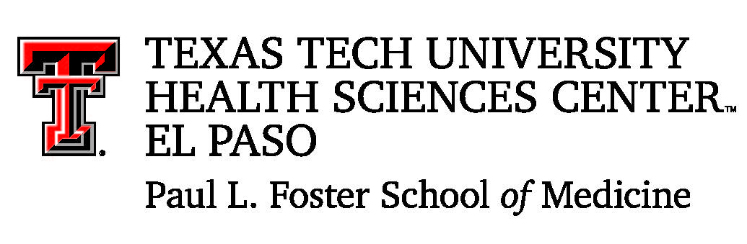
Office of Admissions

Summer Camp Application 2018
Application Deadline May 18

Name: _____________________________________________ Gender: Male or Female
First Middle Last Please Circle

Phone No: ________________ email: _________________________________________
Necessary to inform you if accepted

School attending: _______________________ Ethnicity ______________________

Grade level: (current) _________ GPA (overall) ________ Science GPA_________

Have you taken the PSAT? __________ SAT? __________

Honors and awards: (List any distinctions or honors you have received.)

Use additional sheet if necessary

Extracurricular work or activities: (List any community service or work and any other leadership activities.)

Use additional sheet if necessary.

Have you participated in other programs such as “Adventure for Your Future,” “D.R.E.A.M.S,” Summer Medical Camp, or other types of camps? If so, please list.

ESSAY:
On a separate Word document, with a minimum of 200 words, please tell us why you are interested in the medical field and why Summer Camp would be beneficial to you.

LETTER OF REFERENCE:
Please ask your school counselor or science teacher to submit a letter of reference.

The following are the 2018 Texas Tech University Health Sciences Center El Paso Paul L. Foster School of Medicine summer camps dates:

June 25 – July 6 July 9 – 20 July 23-August 3

Please indicate your preferences in order:

1st _______________ 2nd _______________ 3rd _______________

If selected, we will make every attempt to situate you on your first choice, but understand that this may not be possible.

Submit application and all required documentation no later than May 18.
You may email applications to outreach-elpaso@ttuhsc.edu , fax to 915-783-1265 or mail to:
Office of Admissions
c/o René André
5001 El Paso Drive
El Paso, Texas 79905

I hereby affirm that, to the best of my knowledge, all information furnished as part of my application is complete and accurate. If it becomes necessary for me to withdraw my application, I agree to notify the Office of Admissions so that I will not deprive another student the opportunity to participate. I understand that if accepted into the Summer Camp program, that photographs will be taken for possible use on the website or for other promotional material. I give permission for the Office of Admissions to use these photographs for this and for promotion of its mission.

Student signature: _______________________________________ Date: __________

I give my child ________________________permission to attend any and all field trips deemed necessary by the Office of Admissions to promote educational understanding of its mission and the medical field. If my child is accepted in the Office of Admissions Summer Camp program, I understand that photographs may be taken for use on its website or other promotional material and give the Office of Admissions permission to use them for this and for promotion of its mission.

Parent signature: ________________________________________ Date: __________

