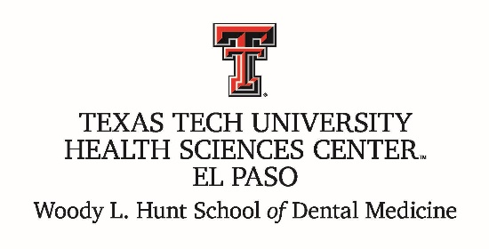

Committee on Admissions

**Chair:**

|  |  |
| --- | --- |
| Wendy Woodall, DDS, MAGD |  |

**Voting Members:**

|  |  |
| --- | --- |
| Kelley Brooks, DDS |  |
| Vernon Burke, DMD, MD, FACS |  |
| Tanya Sue Maestas, DDS |  |
| Paul Ro, DDS |  |
| Victor Sandoval, DDS, MPH |  |
| Daryl Stein-Aguilar, DDS |  |
|  |  |
|  |  |
|  |  |
|  |  |

**Ex Officio, Non-Voting:**

|  |  |
| --- | --- |
|  |  |
|  |  |

|  |  |
| --- | --- |
| Reports to: | Faculty and updates to Executive committee |
| Standing Meetings: | Noon – 1pm, First Thursday of the Month |
| Staff Support: | Andrea Ramirez |
| Terms of Appointment: |  |