TRAVEL CARD ANNOUNCEMENT
June 28, 2005

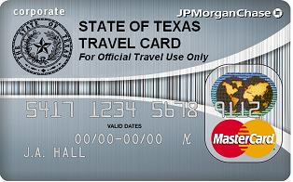

Your name here

DOES YOUR TRAVEL CARD EXPIRE IN AUGUST 2005?

All cards will have the new name JP Morgan Chase with the existing number currently on the card. Remember to activate your card as soon as you receive it. Once the new card is activated, authorizations will no longer be approved on the old card.

If your card expires in August 2005, the distribution schedule is as follows:

Lubbock: New Travel Cards can be picked up starting on Tuesday, August 2nd in Business Services Suite 2C174

Managed Health Care: Cards will be mailed to the individual sites the first week of August.

Amarillo: Cards will be sent to Michele Diaz the first week of August. The distribution schedule will be determined by the campus.

Amarillo (SOP): Cards will be sent to La Wana Boyd the first week of August. The distribution schedule will be determined by the campus.

El Paso: Cards will be sent to Dolores Perez the first week of August. The distribution schedule will be determined by the campus.

Odessa: Cards will be sent to Audrey Land the first week of August. The distribution schedule will be determined by the campus.

OLD “BANK ONE” CARDS
When picking up you new “JP MORGAN CHASE Corporate Travel Card” please turn in the old Bank One card. You can use your new card as soon as it is activated.

Travel Cards not expiring in August 2005

All other travel cards will be good through the last day of the expiration month stated on your current Bank One card.

